Zion Evangelical Lutheran
13511 Roland Lake Road
Skanee, MI 49962

May & June 2024

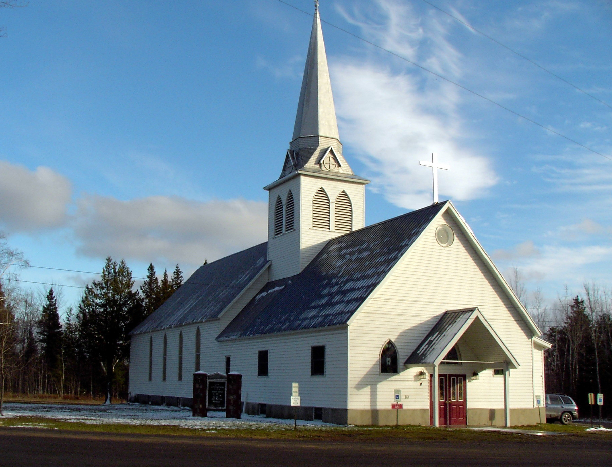

Zion Lutheran Church
13511 Roland Lake Road
Ph: 906-524-6524
Email: zionlutheranskanee@gmail.com



May Schedule
Worship will be at 10 a.m. in the Sanctuary.


June Schedule
Beginning June 2nd, Worship will begin at 9 a.m.
Please note this time change. This will be the regular time of worship from now on.

COUNCIL MEETING
Council Meetings will be May 12th and June 9th following worship (11:15 a.m.)

SERVICE OPPORTUNITIES
Altar guild sign up is in the narthex. If you desire training, please see Sue Bollech.
The choir is always appreciative of new members; see Linnea Barron.

LET US PRAY…. (prayer is service to God and community)
Bonnie Butterworth, Jim Cooley, John Hommer, Ethel Kovala, Roger Jordan, Doug Jukkala, Kathy Magnant, Judy Mattson, Dorothy & Clifford Nankervis, Wayne & Karen Nelson, Mike Peters, Dan Roth, Lois Roth, Cheri Snider, Fawntelle Williams.

(Please take the time to visit our shut-ins – they are a part of our church family and need your prayers, your support, and your love)

All of our military personnel.
Congregations: Wainola Lutheran Church; Bethany Lutheran, Covington; Aura Lutheran Church; Kemi Lutheran Church, Russian Karelia.

(Please keep Lisa up-to-date on who should be added or removed on this list) zionlutheranskanee@gmail.com
.

Dear God, I humbly ask that you heal us from hurt, shame, sickness, and guilt. Heal our hearts, O Lord God. Give us beauty for ashes, the oil of joy for mourning, and let us wear the garment of praise instead of the spirit of heaviness and burden. I pray in Jesus name. Amen.

Family Emergencies, Hospitalizations, or Deaths
Peter Suomela or the church office when these events occur. Our goal as the body of Christ is to provide timely Pastoral Care, Prayer, or Presence in your time of crisis based upon your need.

PLEASE NOTE: At this time, if you are requesting a visit for someone in the hospital, please make the request to the hospital that you would like Peter Suomela to visit.

Bible Readings for May-June

May 5 Acts 10:34-48
Psalm 98
1 John 5:1-8
John 15:9-17
May 12 Acts 1:12-26
Psalm 1
1 John 5:9-15
John 17:11b-19
May 19 Ezekiel 37:1-14
Psalm 139:1-12 [13-15]
Acts 2:1-21
John 15:26-27, 16:4b-15
May 26 Isaiah 6:1-8
Psalm 29
Acts 2:14a, 22-36
John 3:1-17
June 2 Deuteronomy 5:12-15
Psalm 81:1-10
2 Corinthians 4:5-12
Mark 2:23-28 [3:1-6]
June 9 Genesis 3:8-15
Psalm 130
2 Corinthians 4:13-5:1
Mark 3:20-35
June 16 Ezekiel 17:22-24
Psalm 1
2 Corinthians 5:1-10 [11-17]
Mark 4:26-34
June 23 Job 38:1-11
Psalm 124
2 Corinthians 6:1-13
Mark 4:35-41
June 30 Lamentations 3:22-33
Psalm 30
2 Corinthians 8:1-9, 13-15
Mark 5:21-43


JUST A REMINDER
The Suggestion Box, located in the narthex, is still there… Please put any suggestions you have for growing the church. We have received some suggestions already and plan to implement some of them. It will take a little planning to implement a couple of the others, but are excellent ideas and we hope to move forward with them. We thank you so much for making the suggestions. Just know that we need everyone to be involved as much as possible. Some can give of their time and talents more than others, but that is ok, too. We want you to know that it will all be appreciated.

Unfailing Power and Love
But as for me, I will sing about Your power. Each morning, I will sing with joy about your unfailing love. For You have been my refuge, a place of safety when am in distress. Psalm 59:19 NLT
Life is full of moments that try us. Sometimes we run into small obstacles such as car trouble, a squabble with a friend, tension at work. But other times the obstacles are more significant such as the loss of a loved one, conflict within the family or a season of doubt and confusion. Every morning consider the power of your Creator. He is a God who is full of power and love. He acts for your best interests and provides a place of comfort, security, and joy even in the most difficult season. His love for you extends beyond behavior and performance. It isn’t dependent on your circumstances. His love is unending and unfailing. Turn toward this love today and take comfort in your Father.
My Comforter, thank you for this day. Despite challenges I will face, help me remember Your great love for me. Give me eyes to see the ways Your love shows up throughout my day. Give me words to praise Your name and sing joyously of all You have done for me. Thank You, Lord for Your power that goes before me. In each trial I face, help me remain steadfast, faithful, and full of joy. AS I enter this day, help me experience Your all-encompassing love, and let that love transform each moment of the day ahead. I love you, Lord. Amen

We will be warmly welcoming Pastor Bonnie Billock to Zion in June. We will be sharing her with our now sister church – L’Anse Methodist. She officially becomes our pastor as of June 10th, her first service will be June 16th at 9 a.m. We are looking forward to welcoming her and her husband, Steve, to our church and community.
Introducing Pastor Bonnie
Friends,
I am so excited to be serving as your new Pastor! I will admit to being very surprised to find myself not only moving to the snow and cold but becoming a Pastor. You see when I returned to school to begin my journey to ministry it was my plan to be a Chaplain in a nursing home or for hospice. God however had a different plan, and here I am a month away from graduation with a degree far more than I anticipated and becoming an ordained Pastor. God is amazing.
I have a chalkboard that I like to write catchy sayings on. I want to share 2 of those with you, the first is “Don’t ever close a door you did not open” this was said to me by the President Protem of the MidSouth conference. L’Anse Methodist and Zion Lutheran were doors I didn’t even know existed and to be honest I would not have knocked on if I did. God knowing this about me presented this door to me in ways only He could do.
The second saying is “Don’t think, just pack” I never thought I would return to Michigan. Actually, just the week before I had a conversation with a professor that is from Michigan and she said she planned to move back after retirement, I said I will never move back to Michigan. I think God laughed at that. 6 days later I received a call out of the blue. This call from Elder Karin Kaye who introduced me to L’Anse, she told me to talk to my husband and pray about it for a couple of days. After I hung up and told Steve the details, the look on his face was my answer. Don’t think, just pack. I contacted Karin the next day and said YES let’s move forward. I had always wanted to move closer to the Atlantic Ocean but now my heart is on the shores of Lake Superior.
I cannot even express the awe and amazement that I have that God has united my heart to yours. I look forward to meeting you all face-to-face and becoming part of your community.
Your future Pastor Bonnie

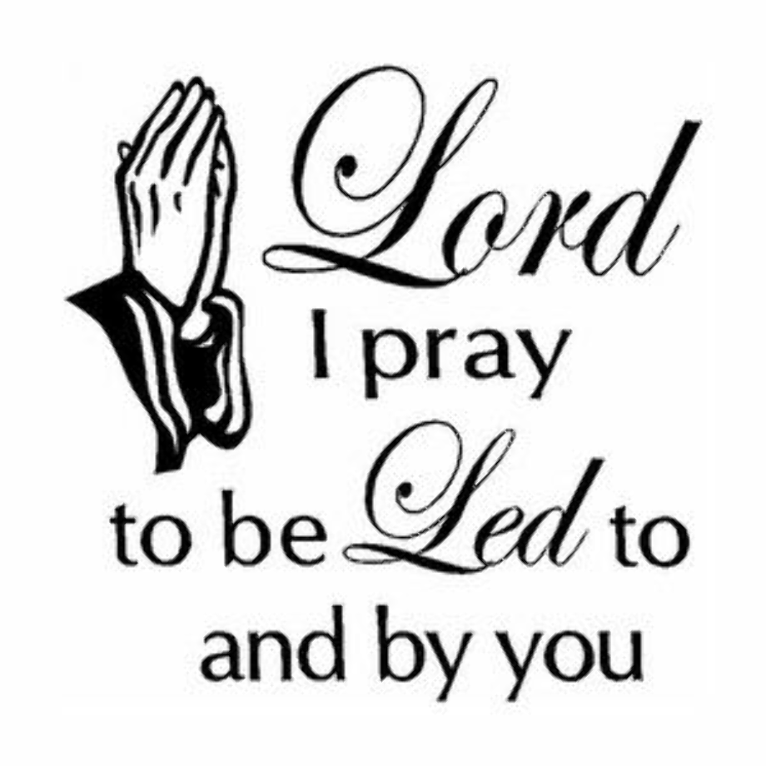

Sometimes it’s hard to pray –
to ask God to heal bodies, mend relationships,
or fulfill dreams, knowing He may not answer
the way we expect.

But He’s promised to always be near,
To soothe aching hearts and racing minds.
To share the weight of our griefs.

God is with us. His presence is
our place of refuge, the answer
to a prayer not yet spoken.
From “In Touch Devoted Living”
Day Spring

