Zion Evangelical Lutheran
13511 Roland Lake Road
Skanee, MI 49962

July August 2024

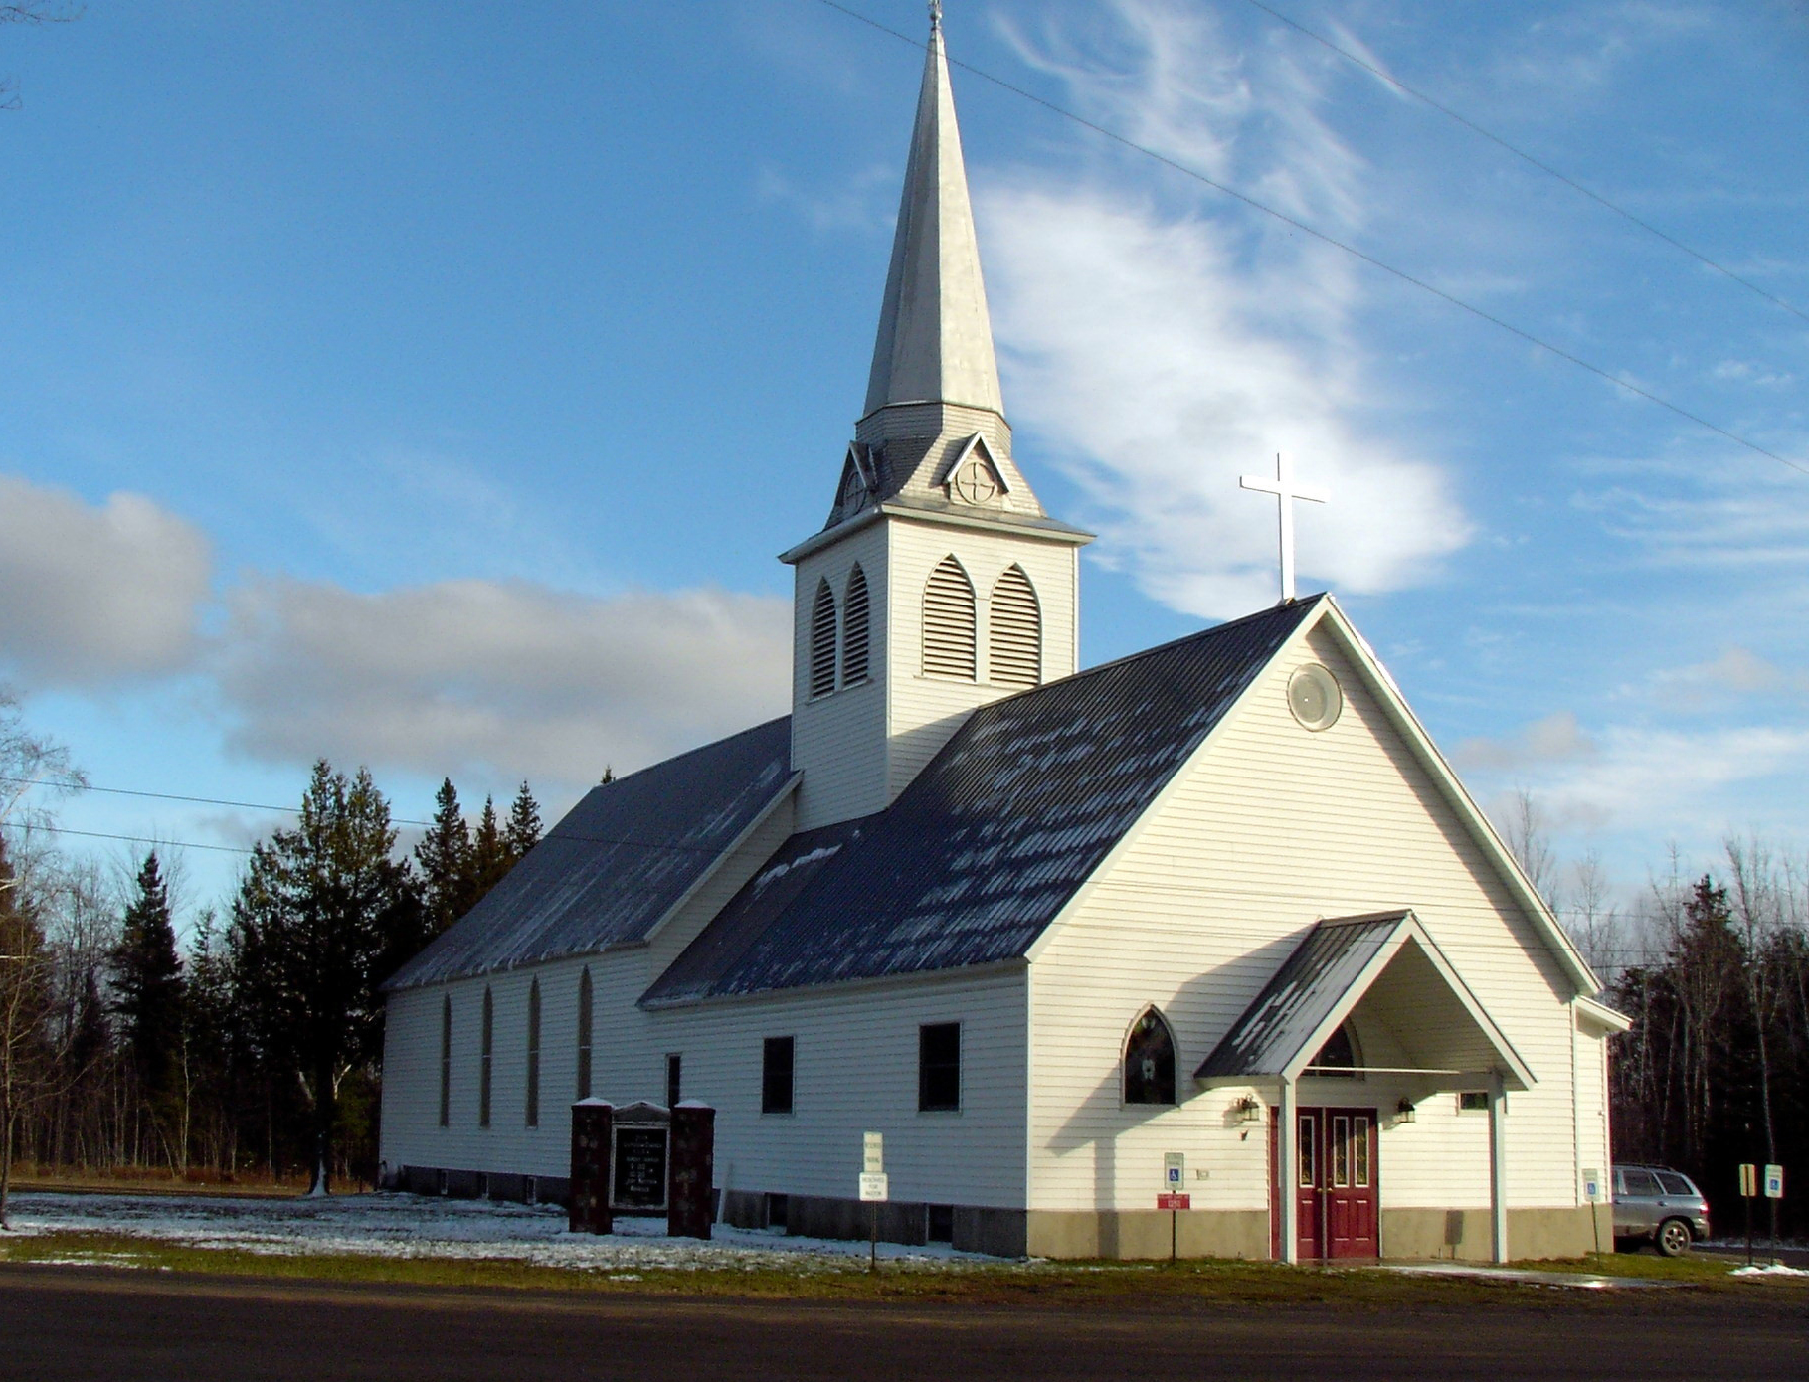

Zion Lutheran Church
13511 Roland Lake Road
Ph: 906-524-6524
Email: zionlutheranskanee@gmail.com

Pastor Bonnie Billock
(906) 524-7936 (parsonage)
(859) 553-9132 (cell)
There is a time for everything, and a season for every activity under the heavens Ecclesiastes 3:1
Now that July is here, I expect to see Christmas everywhere. Stores will have Christmas in July sales, television networks will air all the cozy Christmas shows, and we may even see some Christmas decorations. I, however, will avoid all this; I want July in July. Don’t get me wrong, I love Christmas, but I love Christmas in December. I love that God created seasons, seasons for everything and every activity under the heavens. There is a time for Christmas and a time for July. In July I want picnics, fireworks, hot dogs, warm weather, sunshine and being outdoors. In December I will take snow, cold, and Christmas celebrations galore.
Perhaps, the biggest reason I do not like Christmas in July is the holiness of Christmas is removed. I have never seen any Christmas in July that includes the birth of Christ. Christmas to me is not about sales, parties and cozy movies, it is about the birth of our Savior. So, I challenge those that love Christmas in July to remember the baby in the manager, remember the reason that we as Christians say is the reason for the season, remember the angel proclamation “Glory to God in the highest heaven, and on earth peace to those on whom his favor rests.”
Regardless of if you are a Christmas in July fan or you are like me and just want July in July let’s remember the one who left his heavenly home to be born of a virgin, who took on human form, who battled satan, who lived a perfect life, who faced death on a cross, who took on our sins, who overcome death and rose triumphantly 3 days later, who ascended into Heaven once again and sits on the right hand of the Father. Let us remember Him each day and treasure the gift of redemption He gives us every day of the year.
Pastor Bonnie

LET US PRAY…. (prayer is service to God and community)
Bonnie Butterworth, Jim Cooley, John Hommer, Ethel Kovala, Roger Jordan, Doug Jukkala, Judy Mattson, Dorothy & Clifford Nankervis, Wayne & Karen Nelson, Mike Peters, Dan Roth, Doris Roth, Lois Roth, Cheri Snider, Fawntelle Williams.

(Please take the time to visit our shut-ins – they are a part of our church family and need your prayers, your support, and your love)

All of our military personnel.
Congregations: Wainola Lutheran Church; Bethany Lutheran, Covington; Aura Lutheran Church; Kemi Lutheran Church, Russian Karelia.

(Please keep Lisa up-to-date on who should be added or removed on this list) zionlutheranskanee@gmail.com
.
Dear God, I humbly ask that you heal us from hurt, shame, sickness, and guilt. Heal our hearts, O Lord God. Give us beauty for ashes, the oil of joy for mourning, and let us wear the garment of praise instead of the spirit of heaviness and burden. I pray in Jesus name. Amen.

Family Emergencies, Hospitalizations, or Deaths
Please notify Pastor Bonnie Billock or the church office when these events occur. Our goal as the body of Christ is to provide timely Pastoral Care, Prayer, or Presence in your time of crisis based upon your need.

PLEASE NOTE: At this time, if you are requesting a visit for someone in the hospital, please make the request to the hospital that you would like Pastor Bonnie Billock to visit.


July - August Schedule
Worship will be at 9 a.m. in the Sanctuary.

Cleaning Bee
There will be a Cleaning Bee on Monday, July 8th, at 11 a.m. at the church. Everyone is invited to come and help clean the church.

Worship in the Park
Zion Lutheran Church and L’Anse Methodist Church will have Worship in the Park on Sunday, July 14th at 11 a.m. at the L’Anse Waterfront Park. There will be a potluck following the worship service. Please bring a dish to share. Also remember to bring a chair with you.

Pie Social and Quilt Show
The Annual Pie Social will be held on Sunday, August 4th at 1-3 pm
Quilt Show will be from 12-4 pm

COUNCIL MEETING
Council Meetings will be on the second Wednesday at 4 p.m.
July 10th at 4 p.m.
August 14th at 4 p.m.

Bible Readings for July-August
July 7 Ezekiel 2:1-5
Psalm 123
2 Corinthians 12:1-10
Mark 6:1-13
July 14 Amos 7:7-15
Psalm 85:[1-7] 8-13
Ephesians 1:3-14
Mark 6:14-29
July 21 Jeremiah 23:1-6
Psalm 23
Ephesians 2:11-22
Mark 6:30-44
July 28 Genesis 9:8-17
Psalm 136:1-9
Ephesians 3:14-21
Mark 6:45-56
August 4 Exodus 16:2-15
Psalm 145:10-22
Ephesians 4:1-16
John 6:22-35
August 11 1 Kings 19:1-8
Psalm 34:1-8
Ephesians 4:17-5:2
John 6:35-51
August 18 Joshua 24:1-2a, 14-18
Psalm 34:12-22
Ephesians 5:6-21
John 6:51-69
August 25 Isaiah 29:11-19
Psalm 14
Ephesians 5:22-33
Mark 7:1-13

SERVICE OPPORTUNITIES
Altar guild sign up is in the narthex. If you desire training, please see Sue Bollech.
The choir is always appreciative of new members; see Linnea Barron.
JUST A REMINDER

The Suggestion Box, located in the narthex, is still there… Please put any suggestions you have for growing the church. We have received some suggestions already and plan to implement some of them. It will take a little planning to implement a couple of the others, but are excellent ideas and we hope to move forward with them. We thank you so much for making the suggestions. Just know that we need everyone to be involved as much as possible. Some can give of their time and talents more than others, but that is ok, too. We want you to know that it will all be appreciated.

CONSIDER THIS!
We might think God wants to hear
Only certain things from us—
Thanksgiving and praise,
Intercessions and heartfelt repentance.

But David prayed for his enemies’ destruction
Job protested his suffering;
Giddeon doubted and tested;
Jonah rejected hi calling.

There’s nothing off limits with god –
Every complaint, doubt, failure, and through is safe.
He wants to hear from the real you
And to help you—His beloved child—through it all.

What do you need to tell God today?
From In Touch Ministries.

