Zion Evangelical Lutheran
13511 Roland Lake Road
Skanee, MI 49962

March & April 2024

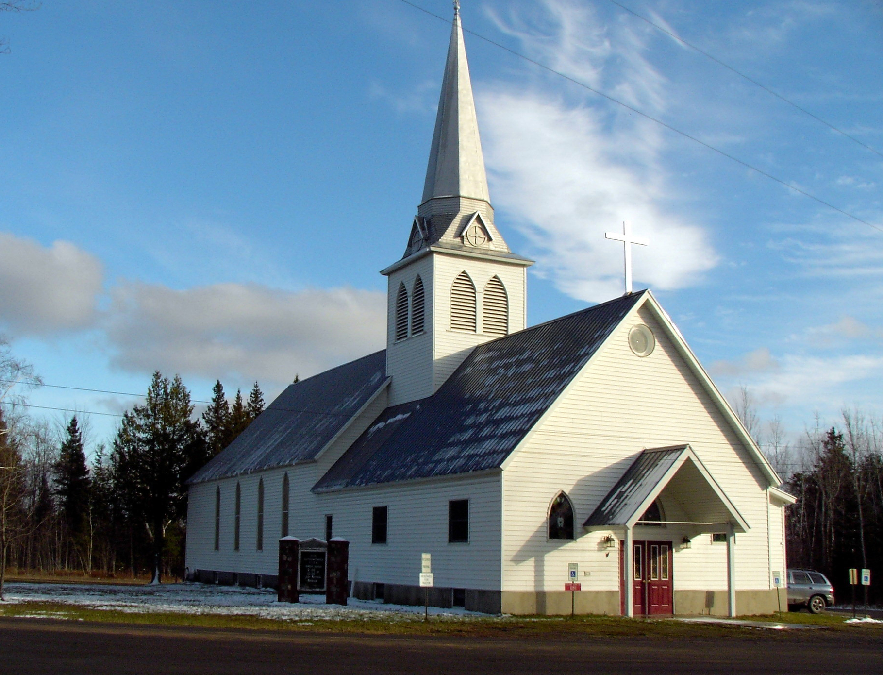

Zion Lutheran Church
13511 Roland Lake Road
Ph: 906-524-6524
Email: zionlutheranskanee@gmail.com



March & April
Worship will be at 10 a.m. in the Sanctuary


Mid-week Lenten Soup Supper and Worship
continues on Wednesdays through March 20th
with Soup Supper at 5 pm
Worship at 6 pm


Good Friday Worship will be on Friday, March 29th at 6 p.m.



Easter Worship will be on
Sunday, March 31st at 10 a.m.

COUNCIL MEETING
Council Meetings will be March 10th and April 14th following worship (11:15 a.m.)

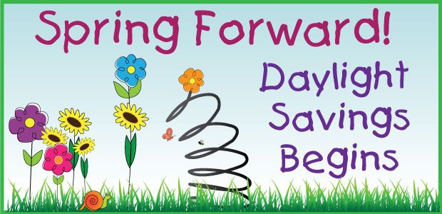
SPRING FORWARD: It is time to turn your clocks ahead one hour on Saturday, March 9th before you go to sleep.

LET US PRAY…. (prayer is service to God and community)
Bonnie Butterworth, Jim Cooley, Ethel Kovala, Roger Jordan, Doug Jukkala, Kathy Magnant, Judy Mattson, Clifford Nankervis, Wayne & Karen Nelson, Dan Roth, Lois Roth, Cheri Snider, Fawntelle Williams.

(Please take the time to visit our shut-ins – they are a part of our church family and need your prayers, your support, and your love)

All of our military personnel.
Congregations: Wainola Lutheran Church; Bethany Lutheran, Covington; Aura Lutheran Church; Kemi Lutheran Church, Russian Karelia.

(Please keep Lisa up-to-date on who should be added or removed on this list) zionlutheranskanee@gmail.com
.

Dear God, I humbly ask that you heal us from hurt, shame, sickness, and guilt. Heal our hearts, O Lord God. Give us beauty for ashes, the oil of joy for mourning, and let us wear the garment of praise instead of the spirit of heaviness and burden. I pray in Jesus name. Amen.

Family Emergencies, Hospitalizations, or Deaths
Peter Suomela or the church office when these events occur. Our goal as the body of Christ is to provide timely Pastoral Care, Prayer, or Presence in your time of crisis based upon your need.

PLEASE NOTE: At this time, if you are requesting a visit for someone in the hospital, please make the request to the hospital that you would like Peter Suomela to visit.

Bible Readings for March-April

March 3 Exodus 20:1-17
Psalm 19
1 Corinthians 1:18-31
John 2:13-22 [23-25]
March 10 Numbers 21:49
Psalm 107:1-9
Ephesians 2:1-10
John 3:14-21
March 17 Jeremiah 31:31-34
Psalm 119:9-16
Hebrews 5:1-10
Mark 10:[32-34] 35-45
March 24 Palm Sunday John 12:12-19
Zechariah 9:9-12
Psalm 118:19-29
Philippians 2:5-11
Mark 14:1-15:47
March 31 Easter Isaiah 25:6-9
Psalm 16
1 Corinthians 15:1-11
Mark 16:1-8
April 7 Acts 4:32-35
Psalm 148
1 John 1:1-2:2
John 20:19-31
April 14 Acts 3:11-21
Psalm 4
1 John 3:1-7
Luke 24:36-49
April 21 Acts 4:1-12
Psalm 23
1 John 3:16-24
John 10:11-18
April 28 Acts 8:26-40
Psalm 140
1 John 4:1-11 [12-21]
John 15:1-8

JUST A REMINDER
The Suggestion Box, located in the narthex, is still there… Please put any suggestions you have for growing the church. We have received some suggestions already and plan to implement some of them. It will take a little planning to implement a couple of the others, but are excellent ideas and we hope to move forward with them. We thank you so much for making the suggestions. Just know that we need everyone to be involved as much as possible. Some can give of their time and talents more than others, but that is ok, too. We want you to know that it will all be appreciated.

SERVICE OPPORTUNITIES
Altar guild sign up is in the narthex. If you desire training, please see Sue Bollech.
The choir is always appreciative of new members; see Linnea Barron.




Dear Congregation Members,
As we enter this new season of partnering with L’Anse Methodist Church to find a pastor, we are working to make the most of our resources. We just moved funds from our checking to a CD account with more interest as suggested by Burt Mason at our annual meeting. We will look at and for ways to stretch what we have while still being the best church and community resource we can be. We will need everyone’s help.
If you know of people that are not attending church, ask them to attend and offer to pick them up, etc.
First and foremost, PRAY. PRAY for the search for a pastor. PRAY for the health and well-being of our church and where and how we reach others. PRAY for guidance for your council and for yourself as we all stretch to see where God is leading us.
- If you have ideas about community outreach, we want to hear them. A few things that we have heard are:
- Having a parent’s night out where some of the church members would help watch/play games with the kids and give them hotdogs and chips for dinner. (maybe ask the Finn’s to donate a couple of pizzas).
- A stuff-the-box campaign inviting them to an evening of sing-along. Also, be sure folks at the marina know we are here.
- Someone even talked about having a kid’s petting zoo with a few of the farm animals on a Saturday.
And, finally while we know that your expenses have gone up with inflation, if you can find your way to increase your contributions it would be appreciated. God can take whatever is given and multiply it in ways we can’t know if we trust him!
We are PRAYING for you all and wisdom as we go forward. It is an exciting time to be part of this church community.
God’s Blessings,
Zion Church Council

